Galerie De Witte Voet presents:

Have the Life of Your Time
Shu-Mei Chan, Takako Higashihata, Anton Reijnders

Exhibition: 9 April till 14 May 2016
Opening: Saturday 9 April 4-6 pm

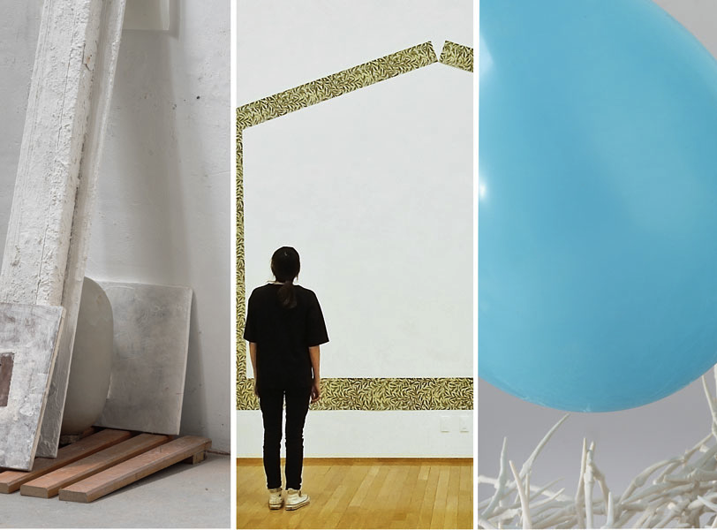
Left to right: Anton Reijnders, Takako Higashihata, Shu-Mei Chan

Galerie De Witte Voet is pleased to announce the exhibition ‘Have the Life of Your Time’ curated by Anton Reijnders, on view at Kerkstraat 135 in Amsterdam, 9 April till 14 May. Opening Saturday 9 April 4-6 pm.

Time – the most determining factor and yet the least tangible aspect in our lives. Despite being constantly surrounded by clocks, watches and smartphones, we hardly ever experience time as something factual. The perception of time is, first and foremost, experience-based, largely shaped by our expectation; as such, a fixed time span can feel like forever or a split second. In the exhibition ‘Have the Life of Your Time’ three artists will display works that reveal, shape, embody and transform time in different ways. In spite of their distinctive approaches and perspectives, Chan, Higashihata and Reijnders share a common fascination with how we can work and play with time.

Shu-Mei Chan (1973), an artist based in Brooklyn, NY, and ’s-Hertogenbosch, NL, flirts with unstable futures. While pursuing post-baccalaureate studies at the New York State College of Ceramics at Alfred University in 2004, Chan took her first steps away from fixed objects. ‘In recent years, I’ve come to think of myself as a constructor of moments’, Chan states. While identifiable forms may appear in her work, they are never permanent and always tenuous. The building blocks with which her temporary forms are constructed often include individually hand-made ceramic elements, which are accumulated over years, and reused over and over. These too, however, break down over time – into shards and inevitably into dust. Therefore, time, as a generative and degenerative force, plays a fundamental role in her practice, both conceptually and as part of the process. During the five-week period at Galerie De Witte Voet, Chan will explore time in real-time and offer viewers an opportunity to participate in its unraveling.

Based in Shigaraki, Japan, Takako Higashihata (1984) proposes that ‘time is reversible’. Using leaps of the imagination, she wonders, ‘If time changes its shape like clay, then maybe time can restore its past shape.’ Since graduating in 2011 from the Gerrit Rietveld Academie, Amsterdam, The Netherlands, Higashihata mines her memory and fragments from the domestic world to create poetic multi-media installations that allow past and present to slip into one another. ‘Time has a circuit-like character. Winter turns into spring, then summer, then fall, then winter, and then back into spring; spring comes again and again. Apparently time tends to restore its shape by itself. Of course it’s not a perfect reproduction – however, you will find similarities between ‘now’ and ‘then’ in many aspects. Smells, sights, textures, and situations will connect you to specific memories that you’ve forgotten somehow.’

The third artist and curator of this exhibition is Anton Reijnders (1955), who has lived and worked in ’s-Hertogenbosch, NL, for nearly 40 years and currently teaches at the Gerrit Rietveld Academie. Reijnders is fascinated by the process of attributing meaning and how time acts as a revealer. ‘Over the years, I have learned to use time as a revealing force while making my work. Sometimes it takes a few seconds to make a piece, sometimes it can take many years. It takes what it takes.’ Most of Reijnders’ works consist of different objects, both found and self-made. They often have been laying around in his studio or used by him for years. Through time he ‘understands’ these objects. As a result, he knows in an instant which object is needed in a constellation. After a piece is ‘finished’ and the euphoria of the new has passed, Reijnders allows time to do its work again – a cycle of living with, forgetting about, and then rediscovering the piece again. This process allows him to see what has come into existence. If after this cycle, the piece still radiates vital energy, it is allowed to exist. The works of Anton Reijnders asks that the viewer let go of preconceived ideas, and above all, that they let time unfold possible layers of meaning.

For more information about the exhibition ‘Have the Life of Your Time’ featuring artists Shu-Mei Chan, Takako Higashihata and Anton Reijnders, or about Galerie De Witte Voet, visit www.galeriedewittevoet.nl or contact info@galeriedewittevoet.nl
Open hours: Thursday through Saturday noon–6 pm, first Sunday monthly 2–5 pm, or by advance appointment
For high-resolution images, please contact info@galeriedewittevoet.nl
Press contact: Annemie Boissevain
© Galerie De Witte Voet, Amsterdam
If you don't want to receive newsletters from Galerie De Witte Voet in the future, please let us know.

